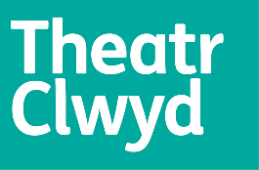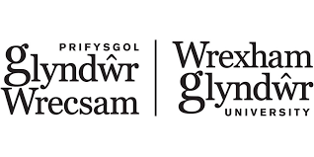

Theatr Clwyd Production Department Placements –
for Wrexham Glyndwr University

Scenic Art Placement

Calling all Glyndwr Arts students –
- Have you ever thought about painting sets and scenery?
- Have you wondered how creative techniques are adapted for stage floors, backcloths and props?
- Do you want to learn how to use your artistic skills in creating amazing sets for a theatre production?

… then come and join us for a short work placement with Theatr Clwyd’s Scenic Artist.

When? w/c Monday 15th May 2023
Days? Times? 3 days per week for 3 weeks – usual working day is 9am – 6pm
Where? MOLD – Theatr Clwyd Scenic Workshop & production site (The Dolphin)
What? Working on scenic elements (set painting and dressing) for our immersive production The Great Gatsby

Theatr Clwyd are pleased to offer a Glyndwr Student the chance to experience what it’s like to create amazing sets and scenery for one of our forthcoming theatre productions. The Great Gatsby is an exciting, immersive, site-specific piece of theatre taking place in The Dolphin pub in Mold town centre during the Summer of 2023. Our creative teams will be transforming the space into different performance areas for the show, and you can join us to see how this work happens.

If you would like to apply for this placement opportunity please go to our website https://www.theatrclwyd.com/take-part/work-experience-volunteering/glyndwr-uni-placements

Closing date for applications: Friday 31st March 2023
Interviews: w/c 17th April 2023

