Open Call Two:
Counterweight Installation

Introduction
Theatr Clwyd is Wales’s leading producing theatre and our work travels the UK. At Theatr Clwyd the voice of the community is embedded in our artistic and organisational life and our work has reached 700,000 people over the last two years through 23 critically acclaimed productions and our ground-breaking arts, health and wellbeing work.

One of only four theatres in the UK to build sets, make costumes and create props in house, we are a resurgent powerhouse; pushing theatrical boundaries to create stunning shows. In 2021 Theatr Clwyd was recognised as the best regional theatre in the UK as part of The Stage Awards.

After 46 years, our Grade II-listed building needs major capital work, with all systems nearing their end of life and conditions deteriorating to the point of becoming unsafe.

After extensive community consultation and working with acclaimed architects Haworth Tompkins, we are embarking on the final stage of a transformative redevelopment that will deliver a much-improved visitor experience and enhanced income-generating facilities within a greener, more efficient, and welcoming building. Our 45-year-old theatre will be redeveloped to create a greener, more efficient and sustainable building for the 21st century.

Central to Haworth Tompkins vision is a new facade creating a welcoming entrance, leading into a reworked foyer space celebrating the views across the landscape.

With an industry-leading zero carbon target and dedicated theatre-making, learning, family and wellbeing spaces, including on-site scenic construction for the first time, the project will be “an exemplar of 21st century cultural space” (Haworth Tompkins).

The public art strategy envisages Theatr Clwyd as a platform for existing and new ideas, considering public art in the widest sense; a space for distinctive site specific artworks, which reflect the theatre’s character, heritage, community and architecture. The proposed programme includes residencies, events, and permanent artworks, as well as digital media, sculpture, architecture and public space design.

We will create and commission public art which is inspirational and inclusive. The public art strategy for the new building seeks to enhance Theatr Clwyd’s reputation as a beacon of artistic excellence and a home for their community.

This opportunity is funded by the Welsh Arts Council ‘Percentage of Art’ legislation as part of the wider regeneration plans for Theatr Clwyd.

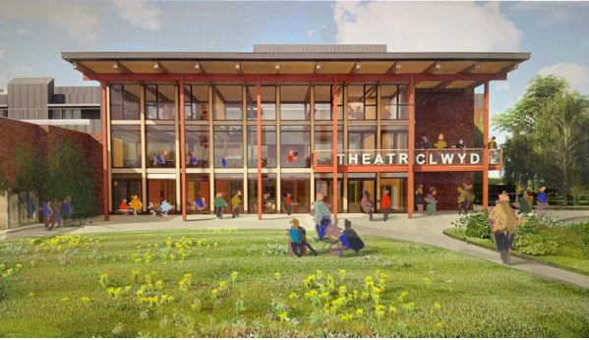
Visualisation of new frontage at Theatr Clwyd

Themes
We have identified three key themes for public art in the new building:

Sustainability
The redevelopment is being driven by a desire to create a building that reduces energy use and minimises the impact of the materials used. Further consideration is also being given to wellbeing, adaptability and resilience.

Community
At Theatr Clwyd the voice of the community is embedded in the artistic and organisational life of the building. Theatr Clwyd have learnt that to deliver meaningful work you have to build trust with a specific, local community and then grow collectively. The artist should look at ways of engaging the community in their process.

Playfulness/Joy
There is an aspiration for the building to be joyful and fun to interact with both adults and children. Theatr Clwyd believes that people being able to engage with the building through play will encourage social interaction and social learning.

Artist Brief
Theatr Clwyd are seeking to commission an artist or multi-disciplinary team to create an installation for their new double height foyer space inspired by and/or utilising parts of the original theatre counterweight system - primarily the pulleys and ropes - which is being replaced in the Anthony Hopkins Theatre.

The counterweight system was installed when the building first opened in 1976, and although in good condition for its age it needs to be replaced to meet current flying safety standards. We would like to celebrate the history of the system and the magic of theatrical flight by commissioning a bespoke installation within the foyer, sparking curiosity and creating connection between the working mechanisms of the theatre and our visitors.

We would like to encourage expressions of interest from multi-disciplinary teams, theatre makers and craftspeople as well as individuals.

Objectives
The key objectives for the artwork are:

- The artwork will provide a strong visual statement within the foyer. The relationship to the double height foyer, views to the exterior and lighting should be considered.
- The lighting scheme for the double height foyer will hang from the soffit and the artwork if projecting out from the wall will need to be coordinated with the lighting scheme.
- A high standard of execution and finish appropriate to the artwork. The foyer will be heavily used and the installation must be robust and able to be cleaned.
- The work is site specific and therefore needs to be sensitive and appropriate to its location.
- The proposal is achievable within the commission budget.
- Work which has been informed by a community engagement process; this process will be established between the artists, commissioners and steering group.
- The history of the original system and its working design purpose needs to be considered in the proposal.
- Coordination with the studio three sixty (the commissioners), Theatr Clwyd, Haworth Tompkins and the main contractor will be required to ensure the appropriate hanging facilities are installed.

Selection Process
This is a two-stage selection process.

Stage One
The first stage will shortlist artists, design teams and theatre makers through an expression of interest assessment, looking at previous work and initial responses to the brief.

To apply, please submit the following to studio@studiothreesixty.uk with the subject heading THEATR CLWYD COUNTERWEIGHT INSTALLATION:
- An expression of interest explaining why you would like to be considered for this project on no more than two sides of A4.
- Up to 10 images of recent work submitted as a pdf with a descriptive list detailing a brief description, dimensions, materials, dates and budget for the works.
- An up to date CV - maximum of 2 pages.
- The name and email address details of 2 referees, at least one of whom can comment from first-hand experience of your professional practice.
- Your own contact details including email address.
- Total file size should not exceed 6mb.

Stage Two
The Stage 2 artists, theatre makers and design teams will be selected based on their expression of interest by the Public Art Steering Committee.

These shortlisted artists, theatre makers and design teams will be invited to prepare a concept design for their proposal for presentation to a selection panel consisting of representatives from Theatr Clwyd, studio three sixty and Haworth Tompkins Architects. Each artist or team will be paid a fee of £750 to develop their concept design.

Interested artists and teams will need to be available on either 15th or 16th January 2024 to present their Stage Two ideas to the selection panel.

Travel expenses will be paid for attendance. If you have any specific requirements to enable you to attend the presentation please inform us after you have received notification of being shortlisted.

The panel will assess interviewees using the following criteria:

- Evidence of understanding of the commission brief
- Quality and relevance of previous artistic work, including ability to provide a creative response to a brief
- Evidence of good communication skills
- Quality and longevity of artwork
- Artists proof of right to work in the UK
- The work will need to be permanent, durable, have a low maintenance requirement and be designed and constructed within health and safety guidelines.

Timescale
The building is due to open in Spring 2025, an indicative timescale is shown below which will be coordinated with the architect and contractors work onsite.

Online Q&A Session: 14:00 2nd October 2023
Deadline for Expressions of Interest 23:59 6th November 2023
Shortlisted Artists/Teams notified 27th November 2023
Shortlisted Artists Develop Concept Designs December 2023/January 2024
Stage 2 Panel Interviews 15th/16th January 2024
Appointment of Artist 26th January 2024
Project sign off and completion 1st February 2025

Budget
The total budget for artist fee, fabrication, delivery and installation of the artwork is £30,000.
This does not include travel and accommodation if required and is inclusive of VAT.

Please send any queries and applications to studio@studiothreesixty.uk with the subject heading THEATR CLWYD COUNTERWEIGHT INSTALLATION.

Evaluation
The Public Art programme is being evaluated by a PHD student from Wrexham Glyndwr University. The student will follow the Public Art Programme through to completion to ensure a thorough evaluation is carried out.

Technical Information
A counterweight system is a flying system designed to allow a single operator to fly scenery and technical instruments easily over stage. The flown items are counter weighted through the cradle situated on one side of the theatre to balance the load on the bars. The system is made up of a number of components - flybars, steel wire rope, pulleys, cradles, rope brakes, hauling lines and the support frame - all these items can be salvaged to create the commission. There is an interest from the commissioners in proposals which incorporate moving parts or kinetic elements, however this is not essential.
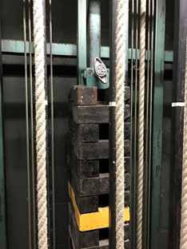
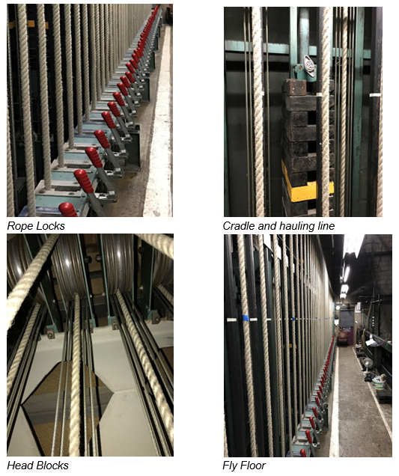
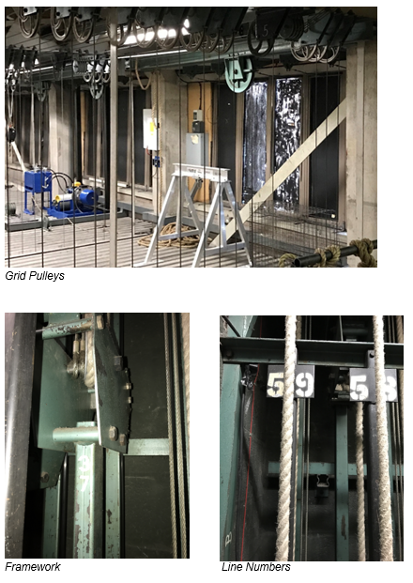

Location
The installation will sit in the double height foyer, visible from the gallery, restaurant area and as you climb the stairs from the main entrance. The maximum space available for the installation is 2.7m tall by 5m long. The artist should consider how much the artwork projects into the space and the impact on views out from the g+2 foyer. The artwork could fix back to the wall or to the soffit above.

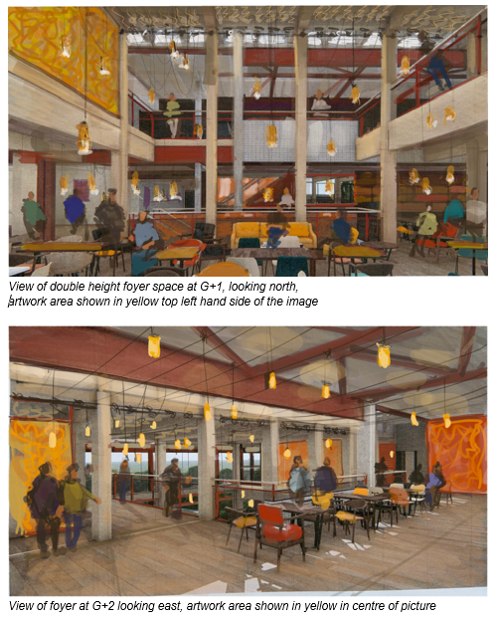
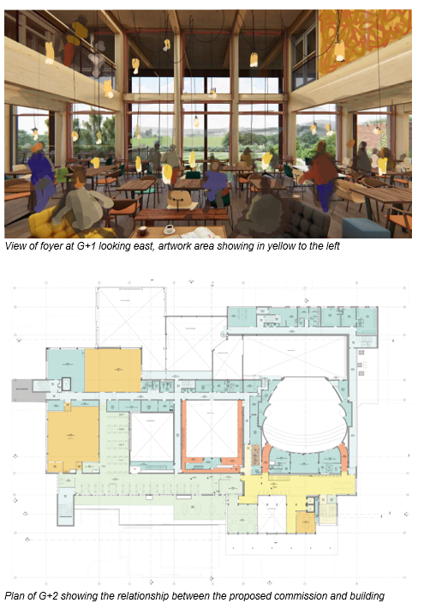

Appendix One: Building Materials Palette
The internal materials palette of the foyer is warm and natural in tone, sustainable and hardwearing. The base palette will provide a backdrop to the colour that may appear in painted surfaces, door colours, artwork and textiles and furniture within the building. The colour palette of the building is shown in appendix 2.

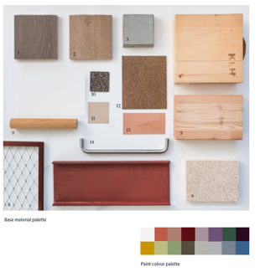
- Engineered oak floor boards (darker tone)
- Engineered oak floor boards (mid tone)
- Concrete sample - representing existing building fabric
- Cross laminated timber (CLT) provides the structure of the new foyer
- Larch glulam timber
- Wood wool ceiling panels
- Red oxide painted steelwork
- Stainless steel webnet - balcony fronts
- Timber handrails for foyer staircases
- Regupol rubber flooring
- Paint colour for painting the CLT soffits in foyer
- Cork Flooring
- Copper
- Stainless steel ironmongery

Appendix Two: Theatr Clwyd Mission and Vision

Our Mission
To make the world a happier place, one moment at a time.

Our Vision
We will be a place to dream - inspiring, limitless, alive
We will be a space to play - messy, invigorating, free
We will be a training ground - rigorous, challenging, supportive
We will be a healing space - encompassing, understanding, safe
We will be a home - for our company, for our communities, for our theatre makers, dancers, musicians and artists, for our facilitators and practitioners, and for our wider world.

Appendix Three: History and Location

The theatre sits on the outskirts of Mold with impressive views over the Clwydian Range including the Area of Outstanding Natural Beauty Moel Famau and the peaks of Moel Gyw and to the south Moel Gamelin. Built in 1976 by Clwyd County Council, Theatr Clwyd was designated a Grade II listed building in June 2019. It is an important example of a civic theatre building originally designed by county architect R W Harvey to serve the region with world-class theatre, arts and education. Central to it’s design was the inclusion of two main theatres, an Education Technology Centre and a series of community spaces.

It architecturally nods towards the brutalist architecture of the era, constructed out of red brick and bands of lead, the bold rectilinear masses express the interior volumes required to form the theatre and ancillary spaces. The Anthony Hopkins Theatre (AHT) was designed as a 550 seat theatre able to accommodate a range of performances. The auditorium has an intimate curved auditorium, the walls clad with ceramic brick tiles applied in a complicated repeat pattern. The AHT fly tower creates a prominent feature of the building visible across the surrounding landscape. The Emlyn Williams Theatre (EWT) reflects the innovation occurring in performance at the time, with it’s adaptable black box form with flexible seating configurations.

Theatr Clwyd was conceived as a regional hub for the development and distribution of educational technology, envisaged to create an opportunity for learning outside the traditional classroom settings. Incorporated in the building was a Television Studio, fully equipped it was initially operated by the largest of independent Welsh broadcasters Harlech Television (HTV) from the late 1970’s until 1992. The old television studio still has the original viewing galleries fitted with leaning glass windows. This space has more recently been used for rehearsals, set building and community groups. On the ground floor the venue also has a cinema seating 120 people.

On the South side of the building is what was originally referred to as the Exhibition Suite now known as the Clwyd Room. This space was conceived to create a self-contained events space for official dinners, events and exhibitions.

Originally the back of house areas were designed to provide facilities for building and making all components of a show onsite, within these facilities is a full working paint frame. The workshop is now located off site due to space constraints and one of the key additions to the refurbishment is the addition of a new double height workshop to bring all makers back onsite.

