Open Call One:
Creative Language Commission

Introduction
Theatr Clwyd is Wales’s leading producing theatre and our work travels the UK. At Theatr Clwyd the voice of the community is embedded in our artistic and organisational life and our work has reached 700,000 people over the last two years through 23 critically acclaimed productions and our ground-breaking arts, health and wellbeing work.

One of only four theatres in the UK to build sets, make costumes and create props in house, we are a resurgent powerhouse; pushing theatrical boundaries to create stunning shows. In 2021 Theatr Clwyd was recognised as the best regional theatre in the UK as part of The Stage Awards.

After 46 years, our Grade II-listed building needs major capital work, with all systems nearing their end of life and conditions deteriorating to the point of becoming unsafe.

After extensive community consultation and working with acclaimed architects Haworth Tompkins, we are embarking on the final stage of a transformative redevelopment that will deliver a much-improved visitor experience and enhanced income-generating facilities within a greener, more efficient, and welcoming building. Our 45-year-old theatre will be redeveloped to create a greener, more efficient and sustainable building for the 21st century.

Central to Haworth Tompkins vision is a new facade creating a welcoming entrance, leading into a reworked foyer space celebrating the views across the landscape.

With an industry-leading zero carbon target and dedicated theatre-making, learning, family and wellbeing spaces, including on-site scenic construction for the first time, the project will be “an exemplar of 21st century cultural space” (Haworth Tompkins).

The public art strategy envisages Theatr Clwyd as a platform for existing and new ideas, considering public art in the widest sense; a space for distinctive site specific artworks, which reflect the theatre’s character, heritage, community and architecture. The proposed programme includes residencies, events, and permanent artworks, as well as digital media, sculpture, architecture and public space design.

We will create and commission public art which is inspirational and inclusive. The public art strategy for the new building seeks to enhance Theatr Clwyd’s reputation as a beacon of artistic excellence and a home for their community.

This opportunity is funded by the Welsh Arts Council ‘Percentage of Art’ legislation as part of the wider regeneration plans for Theatr Clwyd.

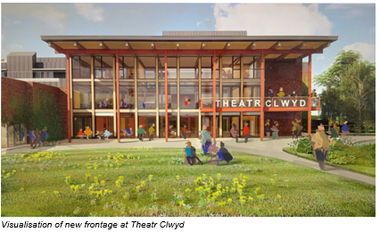Themes
We have identified three key themes for public art in the new building:

Sustainability
The redevelopment is being driven by a desire to create a building that reduces energy use and minimises the impact of the materials used. Further consideration is also being given to wellbeing, adaptability and resilience.

Community
At Theatr Clwyd the voice of the community is embedded in the artistic and organisational life of the building. Theatr Clwyd have learnt that to deliver meaningful work you have to build trust with a specific, local community and then grow collectively. The artist should look at ways of engaging the community in their process.

Playfulness/Joy
There is an aspiration for the building to be joyful and fun to interact with both adults and children. Theatr Clwyd believes that people being able to engage with the building through play will encourage social interaction and social learning.

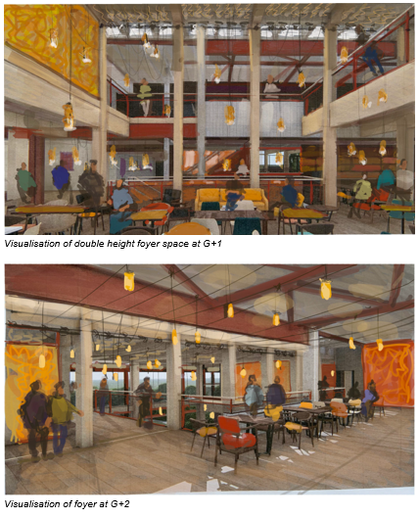

Artist Brief - Creative Language and Wayfinding Commission
We are looking for writers, working as either a solo practitioner or as part of a group, to explore how we can use words, language and storytelling in the new building to welcome and engage with our visitors. Language and stories are at the heart of everything we do at Theatr Clwyd. We want people to meet language and stories as part of every encounter they have with our new building.

We have open minds about how this commission might unfold. The successful artist could take a digital or analogue, verbal or text-based approach. However, legacy is important, and we would like some or all of the successful commission to become part of the fabric of the building for visitors to experience for many years to come.

We hope this commission will encourage our visitors to participate, to feel, to think, to adventure, to use their imagination and to build their own experience of visiting the new building.

We would particularly like to encourage applications from individuals or teams with members who are bilingual or who speak Welsh as a first language. We welcome proposals featuring a creative approach to language and storytelling, utilising Welsh, English, BSL and other minority languages in Wales.

Selection Process
This is a two-stage selection process.

Stage One
The first stage will shortlist writers through an expression of interest assessment, looking at previous work and initial responses to the brief.

To apply, please submit the following to studio@studiothreesixty.uk with the subject heading THEATR CLWYD CREATIVE LANGUAGE COMMISSION:
- An expression of interest explaining why you would like to be considered for this project on no more than two sides of A4.
- Up to examples of recent work submitted as a pdf
- An up to date CV - maximum of 2 pages.
- The name and email address details of 2 referees, at least one of whom can comment from first-hand experience of your professional practice.
- Your own contact details including email address.
- Total file size should not exceed 6mb.

Stage Two
The Stage 2 writers will be selected based on their expression of interest by the Public Art Steering Committee.

These shortlisted writers will be invited to prepare a concept idea for presentation to a selection panel consisting of representatives from Theatr Clwyd, studio three sixty and Haworth Tompkins Architects. Each writer will be paid a fee of £750 to develop their concept.

Interested artists and teams will need to be available on either 15th or 16th January 2024 to present their Stage Two ideas to the selection panel.

Travel expenses will be paid for attendance. If you have any specific requirements to enable you to attend the presentation please inform us after you have received notification of being shortlisted.

The panel will assess interviewees using the following criteria:

- Evidence of understanding of the commission brief
- Quality and relevance of previous artistic work, including ability to provide a creative response to a brief
- Evidence of good communication skills
- Artists proof of right to work in the UK

Timescale
The building is due to open in Spring 2025, an indicative timescale is shown below which will be coordinated with the architect and contractors work onsite.

Online Q&A Session: 14:00 2nd October 2023
Deadline for Expressions of Interest 23:59 6th November 2023
Shortlisted Artists/Teams notified 27th November 2023
Shortlisted Artists Develop Concept Designs December 2023/January 2024
Stage 2 Panel Interviews 15th/16th January 2024
Appointment of Artist 26th January 2024
Project sign off and completion 1st February 2025

Budget
The total budget for this commission (to include artist fee and any community engagement, workshops, fabrication, delivery and installation) is £20,000. This does not include travel and accommodation if required and is inclusive of VAT.

Please send any queries and applications to studio@studiothreesixty.uk with the subject heading THEATR CLWYD CREATIVE LANGUAGE COMMISSION.

Evaluation

The Public Art programme is being evaluated by a PHD student from Wrexham Glyndwr University. The student will follow the Public Art Programme through to completion to ensure a thorough evaluation is carried out.

