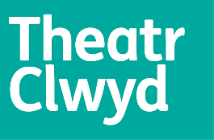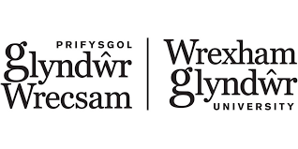

Theatr Clwyd Production Department Placements –
for Wrexham Glyndwr University

Technical Theatre Placement

Calling all Glyndwr students –
- Have you ever thought about getting involved with Lighting & Sound & Technical Stage Management for theatre productions?
- Have you wondered how all the technical elements of a production come together?
- Do you want to learn how to use your technical knowledge and apply it to working backstage in theatre?

… then come and join us for a short work placement with Theatr Clwyd’s Technical Team.

When? Monday 17th April – Friday 28th April
Days? Times? Mon-Fri full time for 2 weeks – usual working day is 9am – 6pm
Where? MOLD – The Mix theatre at Theatr Clwyd
What? Working alongside our Lighting, Sound and Stage teams as we fit-up our forthcoming production of Truth and Dare in The Mix theatre (Theatr Clwyd, Mold)

Theatr Clwyd are pleased to offer a Glyndwr Student the chance to experience what our Technical Teams do to prepare and create shows in one of our theatre spaces. The Mix theatre will be the venue for our brand new productions Truth and Dare in Spring 2023 – and our Technical Team will be responsible for preparing all the staging, lighting, sound and AV elements for the show. The two weeks of the placement will involve being with our team for the prep (fit-up) week and the technical rehearsal week, before the first public shows on the evenings of Thursday 27th and Friday 28th April.

If you would like to apply for this placement opportunity please go to our website https://www.theatrclwyd.com/take-part/work-experience-volunteering/glyndwr-uni-placements

Closing date for applications: Friday 3rd March 2023
Interviews: w/c 13th March 2023

