Open Call Three:
Foyle Room Curtain

Introduction
Theatr Clwyd is Wales’s leading producing theatre and our work travels the UK. At Theatr Clwyd the voice of the community is embedded in our artistic and organisational life and our work has reached 700,000 people over the last two years through 23 critically acclaimed productions and our ground-breaking arts, health and wellbeing work.

One of only four theatres in the UK to build sets, make costumes and create props in house, we are a resurgent powerhouse; pushing theatrical boundaries to create stunning shows. In 2021 Theatr Clwyd was recognised as the best regional theatre in the UK as part of The Stage Awards.

After 46 years, our Grade II-listed building needs major capital work, with all systems nearing their end of life and conditions deteriorating to the point of becoming unsafe.

After extensive community consultation and working with acclaimed architects Haworth Tompkins, we are embarking on the final stage of a transformative redevelopment that will deliver a much-improved visitor experience and enhanced income-generating facilities within a greener, more efficient, and welcoming building. Our 45-year-old theatre will be redeveloped to create a greener, more efficient and sustainable building for the 21st century.

Central to Haworth Tompkins vision is a new facade creating a welcoming entrance, leading into a reworked foyer space celebrating the views across the landscape.

With an industry-leading zero carbon target and dedicated theatre-making, learning, family and wellbeing spaces, including on-site scenic construction for the first time, the project will be “an exemplar of 21st century cultural space” (Haworth Tompkins).

The public art strategy envisages Theatr Clwyd as a platform for existing and new ideas, considering public art in the widest sense; a space for distinctive site specific artworks, which reflect the theatre’s character, heritage, community and architecture. The proposed programme includes residencies, events, and permanent artworks, as well as digital media, sculpture, architecture and public space design.

We will create and commission public art which is inspirational and inclusive. The public art strategy for the new building seeks to enhance Theatr Clwyd’s reputation as a beacon of artistic excellence and a home for their community.

This opportunity is funded by the Welsh Arts Council ‘Percentage of Art’ legislation as part of the wider regeneration plans for Theatr Clwyd.

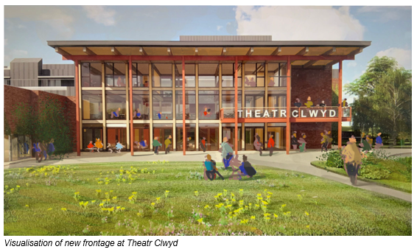
Themes
We have identified three key themes for public art in the new building:

Sustainability
The redevelopment is being driven by a desire to create a building that reduces energy use and minimises the impact of the materials used. Further consideration is also being given to wellbeing, adaptability and resilience.

Community
At Theatr Clwyd the voice of the community is embedded in the artistic and organisational life of the building. Theatr Clwyd have learnt that to deliver meaningful work you have to build trust with a specific, local community and then grow collectively. The artist should look at ways of engaging the community in their process.

Playfulness/Joy
There is an aspiration for the building to be joyful and fun to interact with both adults and children. Theatr Clwyd believes that people being able to engage with the building through play will encourage social interaction and social learning.

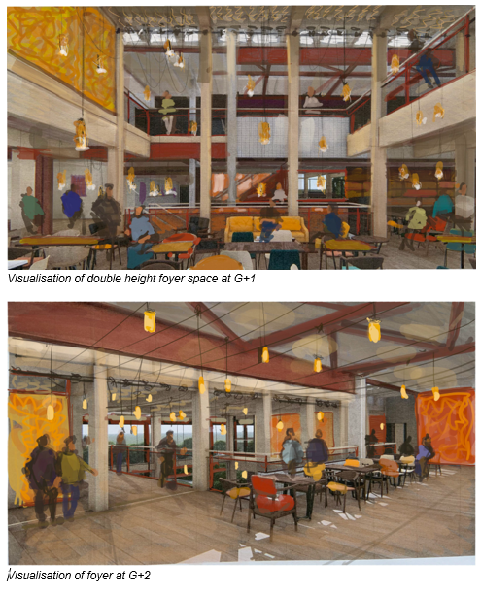

Artist Brief
Theatr Clwyd are seeking to commission an artist or design team to create a bespoke curtain design for the Foyle Room (formerly the Clwyd Room).

The Foyle Room sits on the South Side of the building with views across the Clwydian Range. It is able to be accessed both through the main foyer and separately from an exterior entrance when the main building is closed. It will host a varied programme of activities including weddings, comedy nights, meetings, bar mitzvahs and blood donations.

The Foyle Room is a gathering space, symbiotic to the great historic halls where communities gather. The room has two distinct parts though will often be used as one, and the architecture aims to unify the two sides - a full height space equipped with a lighting grid and an adjacent single height space. The two spaces can be divided by an acoustic screen to create two acoustically separate event spaces.

The curtain will be the centrepiece of the room design. It will be large-scale (approximately 5 metres tall and 33 metres long) and provide options for separating the two spaces as well as an opportunity to bring softness, texture, playfulness and colour into the room.

We are interested in discovering whether there are ways of incorporating a narrative into this commission. Interactivity and storytelling are themes which resonate in all of our conversations about the new building.

This commission is open to different modes of creation and we hope to encourage artists from a wide range of disciplines to apply for this opportunity, including 2D / digital artists and photographers. Equally this could also be an opportunity to explore traditional Welsh needlework and weaving skills. Appropriate technical support can be offered to the winning artist or team to help realise their vision.

Selection Process
This is a two-stage selection process.

Stage One
The first stage will shortlist artists, design teams and theatre makers through an expression of interest assessment, looking at previous work and initial responses to the brief.

To apply, please submit the following to studio@studiothreesixty.uk with the subject heading THEATR CLWYD CURTAIN COMMISSION:
- An expression of interest explaining why you would like to be considered for this project on no more than two sides of A4.
- Up to 10 images of recent work submitted as a pdf with a descriptive list detailing a brief description, dimensions, materials, dates and budget for the works.
- An up to date CV - maximum of 2 pages.
- The name and email address details of 2 referees, at least one of whom can comment from first-hand experience of your professional practice.
- Your own contact details including email address.
- Total file size should not exceed 6mb.

Stage Two
The Stage 2 artists, theatre makers and design teams will be selected based on their expression of interest by the Public Art Steering Committee.

These shortlisted artists, theatre makers and design teams will be invited to prepare a concept design for their proposal for presentation to a selection panel consisting of representatives from Theatr Clwyd, studio three sixty and Haworth Tompkins Architects. Each artist or team will be paid a fee of £750 to develop their concept design.

Interested artists and teams will need to be available on either 15th or 16th January 2024 to present their Stage Two ideas to the selection panel.

Travel expenses will be paid for attendance. If you have any specific requirements to enable you to attend the presentation please inform us after you have received notification of being shortlisted.

The panel will assess interviewees using the following criteria:

- Evidence of understanding of the commission brief
- Quality and relevance of previous artistic work, including ability to provide a creative response to a brief
- Evidence of good communication skills
- Quality and longevity of artwork
- Artists proof of right to work in the UK

Constraints
The work will need to be permanent, durable, have a low maintenance requirement and be designed and constructed within health and safety guidelines.

Timescale
The building is due to open in Spring 2025, an indicative timescale is shown below which will be coordinated with the architect and contractors work onsite.

Online Q&A Session: 14:00 2nd October 2023
Deadline for Expressions of Interest 23:59 6th November 2023
Shortlisted Artists/Teams notified 27th November 2023
Shortlisted Artists Develop Concept Designs December 2023/January 2024
Stage 2 Panel Interviews 15th/16th January 2024
Appointment of Artist 26th January 2024
Project sign off and completion 1st February 2025

Budget

Design
The artist fee for the commission is £5,000 including expenses.

Design, Fabrication, Delivery and Installation
The budget for fabrication, delivery and installation is £25,000 which covers all materials and installation. This does not include travel and accommodation if required and is inclusive of VAT.

Please send any queries and applications to studio@studiothreesixty.uk with the subject heading THEATR CLWYD CURTAIN COMMISSION.

Evaluation

The Public Art programme is being evaluated by a PHD student from Wrexham Glyndwr University. The student will follow the Public Art Programme through to completion to ensure a thorough evaluation is carried out.

Technical Information
The curtain is required to surround three sides of the full height space - approximate height - 5m, width - 33m (exact dimensions to be confirmed). It is important the curtain can be divided into at least three sections to allow for variation of set up but equally work well as one. When not in use it will store gathered in front of the blank wall on the South side which is also perceived as the backdrop for performances within the space. When the curtain is drawn it will be seen through the windows, the artist will work with the fabricator to identify the best aesthetic for the reverse of the curtain. A variety of curtain fullness options are available, thought should be given to how this works with the design. There is a tab track detailed in the building contract to suspend the curtain.

The refurbished Clwyd Room draws direct parallels to the new double story foyer in its base palette. There is visibility of the Clwyd Room from the foyer through an interior mid and low level window. The curtain provides an opportunity for the artist to add texture, warmth, colour and personality to the space. The curtain needs to meet the fire, blackout and acoustic properties required.

The finishes of the room are naturally sourced, timber slatted walls at high level in the east clwyd room, an engineered oak floor throughout and painted plasterboard or joinery surfaces at low level. The warm and natural feel allows the curtain to become the visual focal point.

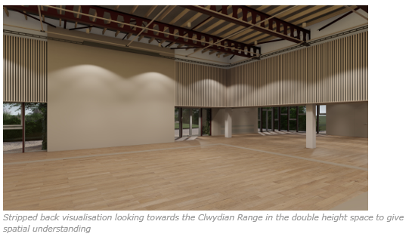
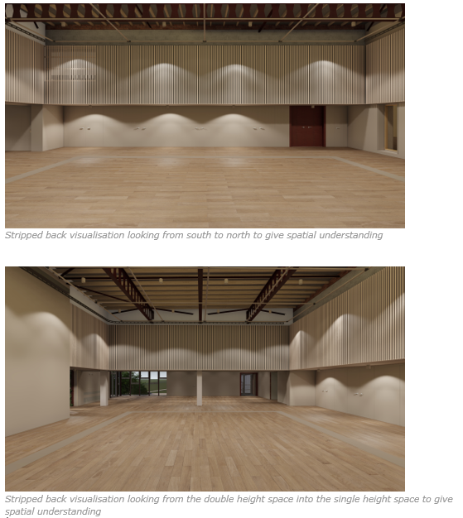
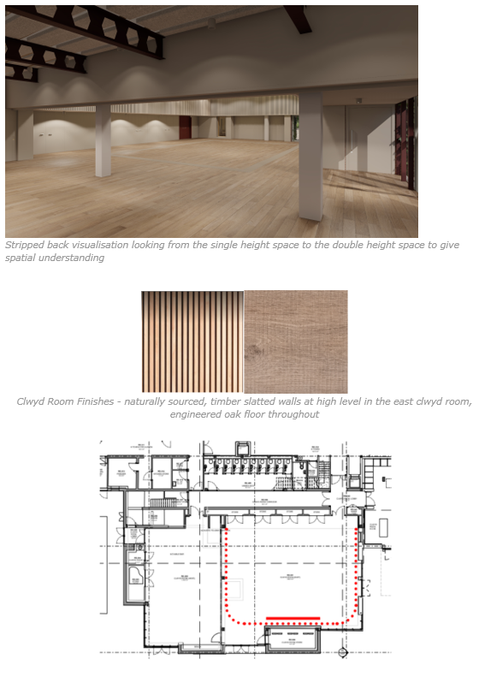

Clwyd Room plan - red dotted line shows full extent of drape, solid line shows location of drape when fully drawn in against the blank wall

Potential Collaboration with the fabricator J&C Joels
Dependent on the expertise and skillbase of the chosen artist or team, the fabricators J&C Joels are able to support this commission by scaling any artwork (if appropriate), advising on material choice and ensuring the technical qualities of the curtain - fire retardancy, blackout and acoustic qualities are accounted for. This will not form part of the artist’s responsibility.

J&C Joels are able to fabricate from any 2D artwork, including drawn or painted artwork, photographs or collage. Samples will be provided to the artist and commissioners for sign off. We hope this technical support will encourage artists from a wide range of disciplines to apply for this opportunity, however we also welcome applications from fabricators or artists who will not require this level of support.

Appendix One: Building Materials Palette
The internal materials palette of the foyer is warm and natural in tone, sustainable and hardwearing. The base palette will provide a backdrop to the colour that may appear in painted surfaces, door colours, artwork and textiles and furniture within the building. The colour palette of the building is shown in appendix 2.

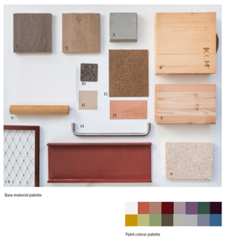
- Engineered oak floor boards (darker tone)
- Engineered oak floor boards (mid tone)
- Concrete sample - representing existing building fabric
- Cross laminated timber (CLT) provides the structure of the new foyer
- Larch glulam timber
- Wood wool ceiling panels
- Red oxide painted steelwork
- Stainless steel webnet - balcony fronts
- Timber handrails for foyer staircases
- Regupol rubber flooring
- Paint colour for painting the CLT soffits in foyer
- Cork Flooring
- Copper
- Stainless steel ironmongery

Appendix Two: Theatr Clwyd Mission and Vision

Our Mission
To make the world a happier place, one moment at a time.

Our Vision
We will be a place to dream - inspiring, limitless, alive
We will be a space to play - messy, invigorating, free
We will be a training ground - rigorous, challenging, supportive
We will be a healing space - encompassing, understanding, safe
We will be a home - for our company, for our communities, for our theatre makers, dancers, musicians and artists, for our facilitators and practitioners, and for our wider world.

Appendix Three: History and Location

The theatre sits on the outskirts of Mold with impressive views over the Clwydian Range including the Area of Outstanding Natural Beauty Moel Famau and the peaks of Moel Gyw and to the south Moel Gamelin. Built in 1976 by Clwyd County Council, Theatr Clwyd was designated a Grade II listed building in June 2019. It is an important example of a civic theatre building originally designed by county architect R W Harvey to serve the region with world-class theatre, arts and education. Central to it’s design was the inclusion of two main theatres, an Education Technology Centre and a series of community spaces.

It architecturally nods towards the brutalist architecture of the era, constructed out of red brick and bands of lead, the bold rectilinear masses express the interior volumes required to form the theatre and ancillary spaces. The Anthony Hopkins Theatre (AHT) was designed as a 550 seat theatre able to accommodate a range of performances. The auditorium has an intimate curved auditorium, the walls clad with ceramic brick tiles applied in a complicated repeat pattern. The AHT fly tower creates a prominent feature of the building visible across the surrounding landscape. The Emlyn Williams Theatre (EWT) reflects the innovation occurring in performance at the time, with it’s adaptable black box form with flexible seating configurations.

Theatr Clwyd was conceived as a regional hub for the development and distribution of educational technology, envisaged to create an opportunity for learning outside the traditional classroom settings. Incorporated in the building was a Television Studio, fully equipped it was initially operated by the largest of independent Welsh broadcasters Harlech Television (HTV) from the late 1970’s until 1992. The old television studio still has the original viewing galleries fitted with leaning glass windows. This space has more recently been used for rehearsals, set building and community groups. On the ground floor the venue also has a cinema seating 120 people.

On the South side of the building is what was originally referred to as the Exhibition Suite now known as the Clwyd Room. This space was conceived to create a self-contained events space for official dinners, events and exhibitions.

Originally the back of house areas were designed to provide facilities for building and making all components of a show onsite, within these facilities is a full working paint frame. The workshop is now located off site due to space constraints and one of the key additions to the refurbishment is the addition of a new double height workshop to bring all makers back onsite.

